SMART WATER MANAGEMENT SYSTEM USING IOT

ABSTRACTION

For human life and the health of the environment, water is important. We have created an automated water quality management system for home, workplaces, etc. in order to achieve the good water quality needed by the citizens through IoT. We have used different sensors to design a device to calculate the water pH, the water pressure, flow, temperature etc. In this paper, we have recommended the use of a smart interface sensor to track water reservoirs, track water contamination and monitor leakages from water pipelines. The water tank level, the water leak detector in the pipelines and the pH sensor have been used to monitor water quality and the water temperature sensor to track the water temperature. They use the ultrasonic sensor for tests. The automation of the system is demonstrated by LabVIEW Software. The device is powered by laptop / mobile phones. With this device installed in smart buildings, we can collect and evaluate the residents 'water usage habits and save a lot of water from waste.

INTRODUCTION

Currently, IoT and remote sensing techniques are being used for tracking, gathering and analyzing data from remote locations in various areas of study. Thanks to the tremendous increase in world industrial production, rural to urban drift and over-use of land and sea resources, people have undergone a major decrease in the quality of water available. In the sector of mining and construction the heavy use of fertilizers in farming and other chemicals have

contributed enormously to the global reduction of water quality.

In IoT water solutions, the data ingest from water supplies can be precisely monitored so that water is handled effectively and efficiently. IoT's intelligent water management has had a huge

impact on water treatment costs and has rendered a cost-effective urban water delivery. The IoT advantages in water management are harvested particularly from the agricultural sector.

OBJECTIVES

* Reduce wasting water
* Improved water quality
* Improve the efficiency of water systems
* Implement leakage control

REQUIREMENTS SPECIFICATIONS

HARDWARE COMPONENTS:

ARDUINO UNO:

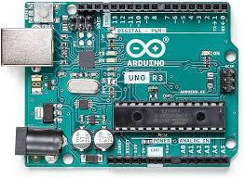

ARDUINO Arduino/Genuino Uno is a microcontroller board based on the ATmega328P (datasheet). It has 14 digital input/output pins (of which 6 can be used as PWM outputs), 6 analog inputs, a 16 MHz quartz crystal, a USB connection, a power jack, an ICSP header and a reset button. It contains everything needed to support the microcontroller. Simply connect it to a computer with a USB cable or power it with a AC-to-DC adapter or battery to get started. Arduino is the heart of our project which is used to control sensors and Wifi module.

NODEMCU (ESP8266):

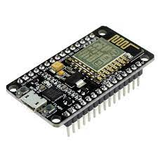

Nodemcu contains built in Esp8266 wifi module which is used to communicate with server thus the sensor data are uploaded into server by connecting to a Wifi Hotspot. We can simply connect our mobile hotspot to the nodemcu and obtain the readings.

WATER FLOW SENSOR:

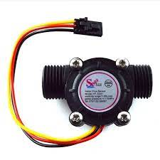

It is used to measure or sense the flow of the water using Hall Effect. Water flow sensor gives an amazing solution for measuring the flow rate of liquids. Huge industrial plants, commercial and residential buildings require a large amount of water supply. The public water supply system is used to meet this requirement. To monitor the amount of water being supplied and used, the rate of flow of water has to be measured. Water flow sensors are used for this purpose. Water flow sensors are installed at the water source or pipes to measure the rate of flow of water and calculate the amount of water flowed through the pipe. Rate of flow of water is measured as liters per hour or cubic meters.

POWER SUPPLY

Power supply circuit, the name itself indicates that this circuit is used to supply the power to other electrical and electronic circuits or devices. We have used 5V DC regulated power supply circuits, which can be designed for converting the available 230V AC power to 5V DC power. 3.5 GSM MODULE It is a mobile communication modem that is connected to a PCB with different types of output and to Arduino board. It helps in establishing communication by inserting a sim card into the slot. This module helps in sending alert message to the programmed number. Once the connection is established successfully, the status/network LED will blink continuously every 3 seconds. You may try making a call to the mobile number of the sim card inside GSM module. 3.6 LIQUID CRYSTAL DISPLAY It is a 16 pin interface that allows us to control LCD display with 5x7 pixel matrix.

SOFTWARE DEVELOPMENTS



Arduino IDE is open-source software that is mainly used for writing and compiling the code into the Arduino Module. It is official Arduino software, making code compilation to easy that even a common person with no prior technical knowledge can easily work on it. Arduino Uno program is fed into the compiler. Arduino Uno can once be compiled and saved for future use, thus the programmed code works as soon as the supply is fed to the Arduino board and the readings are updated.

Water leakage detection 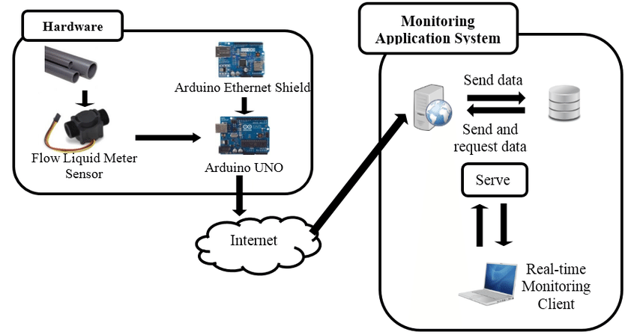

Fig:Block diagram of water leakage detection system

CONCLUSION

Our proposed system is used to reduce the loss of water in apartments by utilizing IoT. In this project, the water flow sensor is used to sense the change in water flow and so the leakage efficiently. Data is simultaneously updated on the web server via Wi-Fi. When leakage is detected the alert message is sent to the officials.